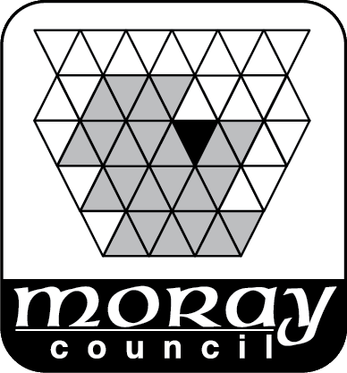 | WAITING LIST APPLICATION FORM  1 April 2026 – 31 March 2027

Customer No:  (For office use) |  |  |  | Register No :  (For office use)
RENEWAL |  | HARBOUR:
NEW | ✓ | HARBOUR:

Vessel owner  First Name |  | Surname

Address |  |  |  |  | Boat Name
Make/Model
E.g. Westerly 45
 |  |  |  |  | Length |  |  |  |  | Mtrs
Postcode |  |  |  |  | Beam |  |  |  |  | Mtrs
Contact numbers | Mobile |  | Landline |  | Keel Type  E.g. Bilge/V keel
Email Address |  |  |  |  | Deck Colour |  |  | Hull Colour
**CURRENTLY UNABLE TO ACCEPT APPLICATIONS FOR FIN KEEL YACHTS IN FINDOCHTY**
TYPE OF BERTH REQUIRED *please delete as appropriate  (if same as current berth please state) |  |  | PONTOON*/OTHER MOORING*/HARDSTANDING*
JOINT OWNERSHIP DETAILS (where applicable) as detailed on the vessel’s insurance policy
2nd Owners Name |  | Email Address
Address |  | Contact Number
3rd Owners Name |  | Email Address
Address |  | Contact Number

Name & Address of Current Insurer*
Policy No |  |  | Expiry Date
Evidence of valid £5Million third party indemnity insurance will be required before a berth can actually be issued.
Signature |  |  |  | Date
Signature | In signing this Berthing Application I have read & accept the conditions of Moray Council’s Berthing Policy and will abide by them. |  |  | Date
Existing berth holders: This form must be completed and returned prior to the deadline regardless of whether there have been any changes to your vessel or not, failure to comply could result in your berth being reallocated.

By email:- buckieharbour@moray.gov.uk
By post: - Harbourmaster, Harbour Office, Fishmarket Quay, Commercial Road, Buckie AB56 1UQ.
Telephone:- 01542 831700

