
REPORT: FALCONER MUSEUM & STORE, VISIT 9th February 2023

FALCONER MUSEUM
Environmental data: The Tiny Tags have been repositioned, though there is no data since calibration, the dataloggers have now been set up to log data. Readings taken using the conservation thermohygrometer, please see the attached environmental monitoring report.

All display cases and open displays were checked for changes in condition of the contents.

GROUND FLOOR DISPLAYS
- On the ground floor in the religion case, potentially active woodworm was indicated by dust beneath the 19th century wooden church collection box, this item was removed from the case wrapped and placed in the freezer.

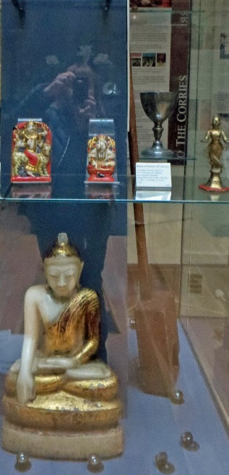 | 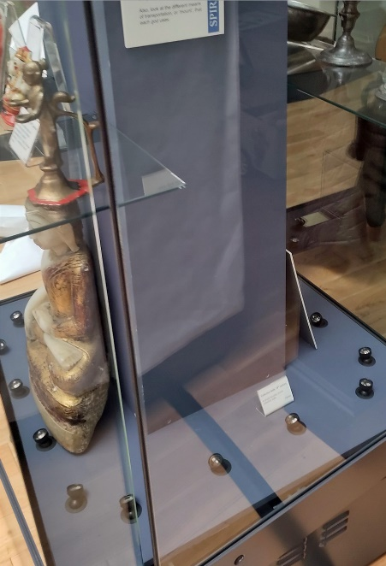 | 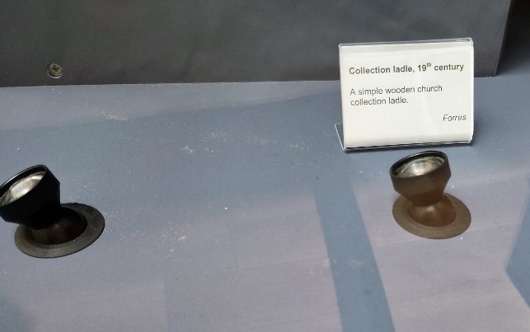  Dust on the base of the case.

FIRST FLOOR DISPLAYS
- A new white plastazote foam support was cut for the BA sword to support its full length
- A recalibrated Tinytag T/RH sensor was placed inside the archaeology case to monitor conditions.
- All museums case contents and open display items were visually checked for change or damage, none was noted all appear stable.
- No pest activity was noted in the museum. However, the blunder trap under the window and next to the Archaeology case did show at least 7 dead woodlice. Not a museum pest but a possible sign of damp conditions.
- There was a water leak stain under the window behind the Archaeology case and another under the window behind the taxidermy case. These should be checked.
- Falconer room, the large elephant skull, we noted some debris beneath. This was checked and appeared to have come from the internal structure which contains much miscellaneous non bone related organic debris. The skull was an open display item and has surface wear from visitor handling. Otherwise appears stable.

ACTION: Next visit

- Check, surface clean to remove dust, then and place the collection box back on display in the religion case

MUSEUM STORE

GROUND FLOOR
Please see the attached environmental report.

Current visit:
The ground floor store was checked.

- The shelving containing the archaeological and architectural stones were checked, there was evidence of some soil/stone debris on the shelf. Not sure how old this was, the surface of the stone querns looked to be stable, although, access was difficult, the area will be cleaned and the situation monitored.

- Selected geology / palaeontology trays were examined. Many of the trays still have dust and small stone fragments in the base due to the drawers not having adequate softening and the contents not being separated. As time allows during visits we will aim to clean and line the trays to reduce this problem. Drawer D:18.4.9 - dead spider but no other pest issues evident.

- The Chairs will continue to be monitored for wood worm activity, none noted on this visit.

ACTION: Next visit

- Continue cleaning the trays to remove insect debris
- Add silica gel sachets to the pyrite affected specimens
- Add softening to reduce physical damage where necessary

GROUND FLOOR FOYER AREA OPPOSITE OFFICE
Large incised stone in case. Acc. No. 1992-16
Monitored – no change this visit.

FIRST FLOOR STORE
Insect Trap Check 09/02/2023
Moth lures all clean, no evidence of flying clothes moth
Blunder traps are located the radiators at front and rear of store – all clean

A walk-through visual check was made for all the shelving bays.

- 9.3.1 Coopered milk/butter churn. Potential active woodworm, placed in the freezer to treat.
- 13.7.1 Cased bird diorama. There are two dead moths visible, these look to be historic rather than recent, we will monitor the situation on the next visit.
- Art Racks: The racks were pulled out and the frames/artworks checked. No new damage noted.

During the checks, there were items showing some evidence of surface loss, mostly from objects having iron components, such as coopered items with iron bands or other attachments. The losses mainly involved minor flaking of loose surface rust onto the shelf. No active or new flash rusting was noted.

ACTION: Next visit
- Specimens and shelving require basic housekeeping measures to remove dust accumulations.
- Start a preventive programme to freeze some of the entomology drawers with ill-fitting or no glazing, especially those showing (probably historic) specimen damage.

Jeanette Pearson ACR
High Life Highland Conservation Service
Inverness Museum & Art Gallery
Highland Folk Museum 22nd September 2022

